

***NCDA Board of Directors Meeting***

**June 16-17, 2025**

**Atlanta Marriott Marquis**

*Marty Apodaca, President Carla Cheatham, Trustee*

*Carolyn Jones, Past President Deanna Knighton, Trustee*

*Dirk Matthews, President-Elect Markell Morris, Trustee*

*Bret Anderson, President-Elect-Elect Jim Peacock, Trustee*

*Julia Makela, Secretary Courtney Warnsman, Trustee*

*Melissa Wheeler, Treasurer Galaxina Wright, Trustee*

*Kathy Evans, ACA Governing Rep Deneen Pennington, Executive Director*

**Monday, June 16, 2025**

**Meeting Called to Order by Marty at 3:10 PM ET**

**1. Roll Call (Julia)**

13 in attendance.   
A quorum is present.

**2. Approval of the Agenda (Marty)**

*Please see June 2025 Board of Directors Meeting Agenda provided on the NCDA Board webpage.*

**MOTION** was made by Julia to approve the meeting agenda with edits as discussed below.

Seconded by Courtney.

*Discussion*

Galaxina would like to add: (1) an update to CDQ with a budget request, and (2) an update on the Counselor Educator Academy.

Dirk would like to add an RFP extension.

Motion passes unanimously (no opposing votes, no abstentions).

**3. Approval of the April Meeting Minutes (Julia)**

*Please see February 2025 Meeting Minutes provided on the NCDA Board webpage.*

**MOTION** was made by Courtney to approve the April 2025 meeting minutes, with edit requested by Markell

Seconded by Galaxina.  
*Discussion:*

The DICI Committee update on Multicultural Competencies will be reported in this June Board Meeting. Indication of activity completion has been removed from the April minutes.

Motion passes unanimously (no opposing votes, no abstentions).

**4. Membership Update (Deneen)**

*Please see the May 2025 Membership Report, 2015 – 2025 Membership Review PowerPoint, and June 2025 Members by Country and Region reports provided on the NCDA Board webpage.*

As of May 2025, total membership is reported at 6,356. The membership PowerPoint provides insights on membership trends over the past 10 years. International membership accounts for 15% of our total, with this demographic continuing to grow. The membership by countries and regions Excel file provides a detailed breakdown of international member engagement. Of the membership types, organizational memberships have experienced considerable growth, while student and retired memberships have been fairly consistent. Fewer memberships come through ACA than did in the past.

Headquarters is still working on data related to retention, particularly in relation to newly-credentialed, international members. Many of the non-renewals from credential holders come from this group (e.g., Saudi Arabia). We are seeking to better understand retention gaps.

Credentials are also on the rise, with 5,969 earned, including 5,050 CCSP; 481 CCC; 274 CMCS; 115 CSCDA; and 49 CSCP. Recognizing that some individuals may hold more than one credential, a question was asked about “what percentage of NCDA members hold a credential”? Could we add this to the membership report information?

The Membership Committee shared several ideas for inspiring renewals but is looking to the Board for implementation. Kimberly Carothers has risen to our attention as a good candidate for further engaging in this work. She both has the skills background (in Public Relations) and has expressed interest in getting more involved. The next step is to reach out to Kimberly to explore potential activities.

**5. Treasurer’s Report and Finance/Budget Related Business**

***a. Treasurer’s Report***

*Please see the May Treasurer’s Report provided on the NCDA Board webpage.*

*Revenues.* We are more than halfway through our fiscal year and we are achieving some of our revenue targets so far. As of the end of May 2025, our total conference revenue was trending lower than budgeted, but we know our international members were having trouble with visas and members have reported not being supported in conference funding from their employment. Non-member subscriptions are doing surprisingly well. With the carry-over King Saud University funds, we are at 80% of our revenue targets. The TEC, Credentialing Commission, and Membership are doing well. We also have the miscellaneous revenue from the Idaho chapter.

*Expenses.* We have spent about 58% of what we budgeted this year; this is on track where we are in the fiscal year. A few columns are trending high or over budget including the magazine, technology, international collaboration costs, and government relations. As reported in our last meeting, we did pay for the government relations tracking software a whole year in advance so that number will look higher at this time. For the magazine costs, again, we need to review the costs of printing and postage to see if this is an area to increase in the budget or see if other options are available. Our next report will have a bulk of the conference expenses.

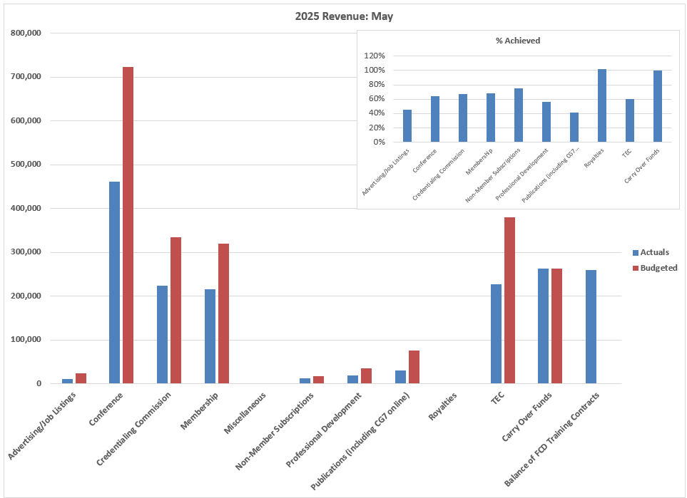

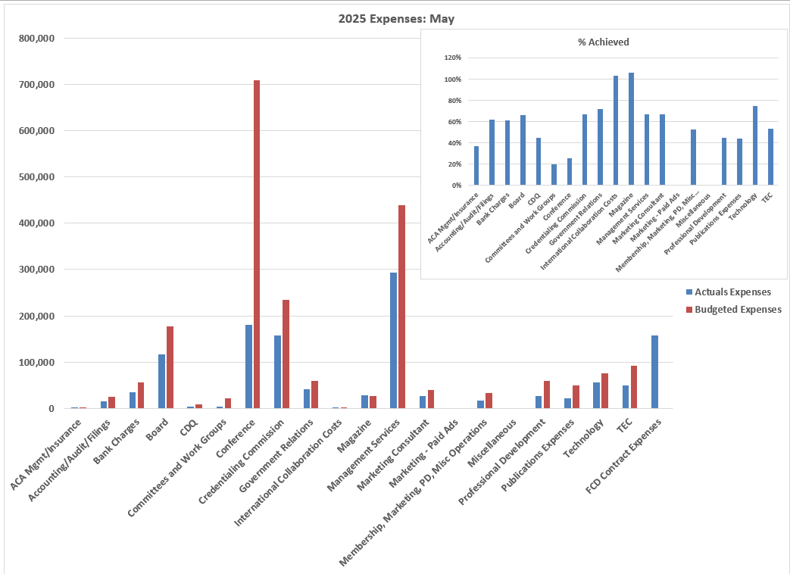

***b. Budget Planning for Next Year***

In an effort to allow the Finance Committee, President-Elect, and others to better prepare a budget, we are asking that all Committee Chairs, Trustees, Groups, and Board members have any budget request submitted in writing to the Treasurer and Executive Director by August 15th.

When we have the budget discussion, we want to include all requests together versus breaking these up throughout the meeting. During the budget conversation, Board members will be presented with data necessary to understand the percentage each expenditure encompasses in our total budget, anticipated increases in revenue and expenses based on past trends, and an analysis of the costs of goods and services for our major initiatives as an organization. We hope this will increase transparency related to the budget.

A Google Form has been created for committee chairs to submit budget requests. It is the same form we used last year. We ask that committee chairs review requests with their Board liaison. Please start brainstorming now in your committee liaison conversations. Anything $50 or less for the year does not require a budget request. After October 1st, our budget is fairly set for the year. Committees can submit delayed proposals, but requests will only be approved if funding exists at the time. Approvals are more likely to be made in a timely manner if proposed in the cycle at the beginning of the fiscal year.

***c. CDQ Budget Request***

Melinda, the CDQ Editor, as asked if they can increase their issue stipend by $500. Currently, we are at $2,000 per issue, with issues released four times per year. The intention is to provide an association editor with $500 per issue because of the current volume of submissions creating a considerable workload. For example, as of June 2nd, we have received 113 submissions just this year.

**ACTION ITEM:** Galaxina, please share with the CDQ that “Yes, we are in support of hearing your proposal. Please submit this with the forms due on August 15, 2025, and we’ll plan forward for the FY2025-2026 which begins October 1, 2025.”

***d. Finance Committee Budget Request for Organizational Consultant***

The Finance Committee recommends motion to Board to add additional expense for the organizational consultant to the current budget. The Executive Director is authorized to move money from Mabrey Cash Flow or checking accounts to cover expenses not covered by the annual revenue.

**MOTION** was made by Julia to add the additional expense for the organizational consultant to the current budget, as well as to authorize the Executive Director to move money from Mabrey Cash Flow or checking accounts in amount up to $10,000 to cover expenses not covered by the annual revenue.

Seconded by Courtney.  
*Discussion:*

Note that we have not yet selected someone for this role. We will still negotiate cost and timeline. But, this allows us to move forward once the selection is made.

Motion passes unanimously (no opposing votes, no abstentions).

***e. Financial Policies***

The Finance Committee has drafted financial policies for NCDA. The draft was sent via email, and comments or feedback are welcome. The policies were based on input from our auditors, and include: a gifts policy, assets allocation plans, operating funds and reserves, etc. The aim is to: (1) gather input, and then (2) seek approval via Board eVote. This would allow us to move forward by communicating with a wealth management advisor or financial advisor regarding our investments.

**ACTION ITEM:** All Board members are asked to review the draft financial policies document and to provide feedback, comment, and/or question to Missy by August 1, 2025. Note that this is a “heavy” document, and the desire is to have it written for a lay audience. Questions are welcome.

Once the document is reviewed and approved, the Finance Committee will take next steps in line with its guidelines.

***f. Travel Policies***

Proposed revisions to the travel policy were sent via email, in a document with tracked changes. Board members are asked to review this document and provide feedback or ask questions.

Strategies were discussed regarding reimbursement for airfare for International Board Members. It is time to document our approach, as there is an expectation that we are likely to have Board Members from international locations next year. After discussion of options that would be appropriate and fair, we determined that we would approach this year from an inclusivity perspective and simply budget for the increased cost. International Board Members will not be treated differently from domestic board members regarding meeting attendance. We also recognized that there is now an option for hybrid meeting attendance, for example, if the long flight travel is not feasible for brief fall and spring meetings. However, meeting attendance would be required in person at the annual conference.

Finally, it was noted that there is a Routespring policy that all requested domestic airfare rates over $800 require approval from the Executive Director and the Treasurer. A similar fair approval policy may be in place for international travel to help us monitor costs. This first year will be considered a “pilot” as we experience the implications of this new need.

Finally, questions were asked about when and how mileage and per diem rates were established. It was shared that these are reviewed annually, in line with NCDA’s fiscal year. For the upcoming year, a suggestion was made that the Finance Committee could review these in comparison to ACA’s rates.

**ACTION ITEM:** The Finance Committee will review milage and per diem rates for the upcoming fiscal year.

**ACTION ITEM:** Board Members are requested to provide any feedback to the NCDA Travel Policy document to Missy by August 1, 2025. She will then seek a motion to approve the policy.

***g. Questions on recent submission***

A member of the Training and Education Council (TEC) recently submitted reimbursement requests for the entire year, including the Albuquerque (October 2024) and Nashville (February 2025) meetings. Our travel policy states that we have 60 days to submit for reimbursement. Appeals to this request must be approved by the Executive Committee. The reimbursement requests amount to $281.36 for the Albuquerque meeting and $145.67 for Nashville. A motion is now needed to approve these reimbursements.

**MOTION** was made by Missy to approve these reimbursements for the Albuquerque and Nashville meetings, which were submitted late.

Seconded by Dirk.

Motion passes unanimously (no opposing votes, no abstentions).

**Tuesday, June 17, 2025**

**Meeting Called to Order by Marty at 9:04 AM ET**

**6. Headquarters Report***Please see reports for HUB Update/Considerations, Video Prompts, and Conference Update/Stats provided on the NCDA Board webpage.*

***Career Practitioner Conversations Podcast***

The NCDA podcast series is going strong with 73 episodes released between July 2024 and June 2025. We have listeners in 106 countries, and more than 22,000 downloads. Sessions are booked for several months to come.

***NCDA Hub***

The NCDA Hub initiative was started based on a survey conducted in 2021, reflecting a need for online and self-paced professional development opportunities. All offerings are asynchronous and self-paced. Currently, we offer 22 courses, and up to 55 possible CEs. Courses range from 1 to 10 CEs each, and every month one course is offered at a discount.

To date, the Hub is underutilized – both in terms of the number of people using the system and the use of functionality / features. A review of the current status of the NCDA Hub has led to six recommendations:

1. *Increase awareness.*  
   It would be advantageous to review materials that are sent to new members. Can we add links and references about the LAS Hub to new members, as well as FCD training and credentialing webpages? Can we create brief videos for information sharing? Perhaps some FAQ-type posts on our social media (currently most LAS Hub-related posts have been about discounts)?
2. *Explore offering limited free CE earning opportunities.*   
   Experience seems to show that once someone engages in an NCDA Hub offering, they are likely to come back for more. What would it take to offer something for free to draw people in?
3. *Consider incorporating live and recorded webinar series in the NCDA Hub.*   
   This was pilot tested last year. It will take some development work. But, the more programming we can have flowing through the NCDA Hub, the more visibility the platform receives. Initial users who come for a webinar are more likely to come back to select another offering.
4. *Focus groups.*   
   Can we host focus groups of “core users” – defined as people who have come back for multiple programs (e.g., 4 – 6 times). Let’s ask for feedback on what we have available. What are you looking for? What topics would you like more of? What learning formats have been most helpful? This will help us plan for CE needs and budgets.
5. *Audit recently submitted CE logs of NCDA credential holders.*   
   How are NCDA credential holders getting their CEs – in practice? How can we replicate this?   
   Are their particular needs for CE users. For example, it can sometimes be challenging to find professional development opportunities for the “supervision and ethics” topics. Perhaps this could be an areas to focus our offerings.   
   (This may be a great project for a Leadership Academy cohort to work on.)
6. *Is any rebranding needed?*  
   Rebranding can mean a lot of things. We recommend holding on the rebranding conversation while doing other research, but want to acknowledge it as a possibility. For example, do we need to add the word “learning” to clarify the purpose of the “Hub”—(e.g., “NCDA Learning Hub”).   
   *It was noted that rebranding is not a current project focus for the Board. It could be considered if it flowed from exploration and suggestions.*

Currently, we calculate our cost at $35 per one CE. Yet, if courses go past 5 hours, we start to discount that rate. We emphasize this pricing, as it is lower than many other places. It may be helpful to review the “cost comparison” graphic that credentialling offers. Do we want to replicate something like this?

Several models of wooing members in were brainstormed, such as:

* A yearly subscription for the site. Then you could take as many CEs as you would like to pursue.
* Every member gets one free CE per year? (with the goal of getting them in and interested?)
* Scheduling big push times – end of year, end of budget year (June 30) – encouraging the use of remaining budget.

***Career Developments***

Our *Career Developments* budget has run high this year due to the number of members requesting print copies. While most members receive it in PDF, print copies are currently requested by 1,113 members. The print publication and layout are quite attractive. The PDF is not quite as engaging.

Though, there are some electronic tools which may increase the visual appeal of the electronic version. For example, IAEVG offers a flipbook for their eMagazine using a product called Heyzine. The cost for what we would need would be approximately $8 per month, and we would be able to match this with an audio plugin (which is not possible with our current PDF). Some research is needed to explore this option. Would members be interested and use this? And, how functional is it on various devices? Also, how would the new format affect our layout designer’s work – if it does at all?

The first step may be to reach out to Jaana Kettunen. As IAEVG President and a longtime NCDA member who has been engaged in our Technology Committee, she may be able to provide some helpful insights. If the flipbooks look like a strong option, we might want to consider it for other NCDA publications as well.

***Trinity Audio & Accessibility***

Since the recent launch of the audio play feature with *Career Convergence* articles, we have seen an engagement of approximately 150 articles being “played” per month. This is about 9% of *Career Convergence* visitors using the audio feature. We have not received much feedback, but all feedback that has been received is strongly positive, demonstrating appreciation for the service.

It was expressed that regardless of the engagement numbers at this time, the service is perceived as valuable for enhancing the accessibility of our materials. That said, we recommend increased marketing to support awareness and continuing to monitor usage. We are still early in the timeline of offering this service, and there is much potential for growth.

Additionally, a request was made for transcripts be posted for podcasts moving forward. This is helpful for those integrating podcasts into classroom assignments, as well as for accessibility more generally.

***New members eBulletin***

A new look has been released for the members eBulletin, increasing consistency and visual appeal. We have received positive feedback on this.

***Website Management***

NCDA Headquarters reports being very happy with TCS, the technology contractor that helps support the website. They are receiving a “drop-report”, which is a monthly list of items that will disappear from website in 60 days. For example, there are some *Career Convergence* articles that were flagged for reaching the 10-year limit on what is included on the website. This allows Headquarters staff to monitor content changes and make updates as needed.

***Social Media***

Approximately 91% of people who are interacting with our social media accounts view them through a mobile device (as opposed to a desktop computer). Across all five of our channels – Facebook(Meta), Instagram, LinkedIn, Threads, X) – a total of 33,475 people are actively following us. Of these, LinkedIn is particularly popular with 22,000+ followers.

*Analytics and Paid Ads*

Social Media analytics on most active posts suggest that NCDA Members “love to get involved.” Our posts that outperformed this year address topics such as: (1) seeking assistance with probono career professional work for laid off workers, and (2) writing an article for *Career Convergence*. The next most engaging level of posts were problem- and solution-based. For example: (3) “Do you need last minute CE hours? Here’s how!”

In recent months, we posted paid ads on LinkedIn and Meta. LinkedIn performed well compared to the industry average. Yet, although we spent less money on Meta, this provided big returns compared it the minimal spend. Additionally, on Meta, ads about Credentialling performed twice as well as those about the conference. Why might this be the case? A guess is that perhaps on LinkedIn, people already feel they know what we are about. On Meta, we may be newer to the audience.

Going forward, the recommendation from Katy is to flip the focus of our funds – to spend $800 on Meta and $500 on LinkedIn. Additionally, we can focus on offerings in the NCDA Hub and those related to Credentialling. This will help us consider return on investment with more tangible numbers. Do we experience changes in purchasing?

*Strategies for Social Media Post Content*

Upcoming social media posts will focus on: (1) short videos from Board and association members about the value of the association / getting engaged, (2) *Career Convergence* – with article authors talking about their writing, (3) problem and solution style FAQ information, (4) social trends, accessibility, etc. Katy also plans to tag authors and webinar presenters on LinkedIn so that they can repost and share information with their networks.

We also discussed strategies for when and how to communicate information about State accomplishments and events. Can NCDA repost information about state events? Or, can they create posts that highlight State engagements to bring attention to their work? Perhaps we could add the marketing or communications person to the State contacts form (similar to the way we have a list of government relations people at the state level)? Some States have more infrastructure for this than others.

**ACTION ITEM:** Markell, Melanie, and Deneen will connect to plan a State contact list, strategy, and communication timelines for the purpose of marketing – supporting all States to promote their events and attract more engagement.

***Brand Guidelines*** ***for digital use***.

Katy is working on set of brand guidelines for digital use. It will share colors, primary fonts, subfonts, etc. to promote a consistent look across NCDA materials and communications. She will bring these to the Board for review.

**ACTION ITEM:** Katy will draft a set of NCDA brand guidelines and bring to the Board for review.

***Conference Video Project***

Katy will be filming short (30-second) FAQ-style videos at the conference, and has requested Board Member participation. These videos will be posted across social media platforms, and perhaps also on the website and/or the NCDA Hub. The goal of the videos is to put a personal face on NCDA – to build relationship connections with key audiences.

***Conference Statistics***  
As of June 10, 2025, a total of 942 people had registered for the conference (92 were virtual only). Of these, 29% were first timers. 56 were international attending from 17 countries. The Professional Development Institutes (PDIs) did not sell out this year, but all 9 received attendance, and several resonated strongly (e.g., Career Construction – 41; Integration Career Development into Advising – 29; Breaking Down Barriers – 24; Coaching with Hope – 22).

This is a great content year. 52 recordings are ready for the virtual platform. We are expected to come out with a profit from the conference if we can reach 200 virtual attendees.

***Contract Updates***

Several updates on contracts were provided as well:

* During the conference on Thursday, we are scheduled to sign a contract with the Qatar Finance and Business Academy.
* Discussions with Maximus continue regarding potential training contracts.
* We were contacted by the Massachusetts Department of Labor to engage in an open bid for a career development training contract. More to come on this following the conference.
* A career conference is being held in Saudi Arabia connected to our contract work, and they are interested in Board Member attendance.

**7. Treasurer’s Report and Finance/Budget Related Business, Continued**

***h. Discussion of Presidential Stipends (Jim)***

**MOTION** made by Jim to we move the increase in the $10,000 for presidential year which was approved in October 2024, to provide a $10,000 stipend for the president-elect year, retain the presidential stipend at $20,000.

Seconded by Missy

***Discussion***

Earlier this year, a vote was made to increase the stipend in the Presidential year, recognizing the volume of work that the Presidents take on and the strain that this adds when time is taken away from gainful employment – particularly for private practitioners who take on this role.

An additional reflection was made at this time that President-Elects are being asked to take on more than ever before. This is particularly in respect to travel (including internationally), relationship building, and presentations. The request is not for more funding at this time, but rather to spread out when the funding is provided. Could we move the $10,000 increase to be given in the President-Elect year, while retaining the Presidential stipend at $20,000?

There may still be some room for exploration and benchmarking here. Carolyn made an appeal for still needing to increase the Presidential stipend, as $20,000 was still not enough to support the financial loss experienced by those in private practice. On the other hand, ACES only pays $7,000 as a Presidential stipend. We may need to research what other organizations are doing in terms of standard operating procedures, with consideration of the roles their leadership play.

Today, we are not asking for more funding; simply a reallocation on timing of distribution.

Motion passes (11 yes, 2 abstain).

**8. Action Items**

***a. International Pricing Research (Jim, Carolyn, Dirk)***

Research conducted since our April Board meeting has revealed that, while not all associations offer discounts to international members whose economy is not the same as US, some key partners to engage in this practice (e.g., APCDA, IAEVG).

**MOTION** made by Jim that NCDA offer a 30% reduced price for all members who live in a country designated by the annual World Bank Classification as Low Income, Lower Middle Income, Upper Middle Income, for Membership and Professional Development Options in which we charge registration (conference, institutes, HUB courses, webinars, Master Trainer Training).

***Discussion:***

This discount would not be applied to training manuals or books in the NCDA Career Resource Store. There is no implication that the discount is relates to training conducted by instructors outside of the NCDA central office.

This is not anticipated as a “game changer” for the association in relation to budget. Rather, it is a motion of good will, recognizing the broader experience of our international membership.

Seconded by Carolyn

Motion passes (12 yes, 1 absent).

***b. Scholarship program ideas***

Carolyn asked if a scholarship program could be established to offset the cost of registration to attend the annual global conference for those from lower income backgrounds or institutions that do not have funding to support conference attendance. It may be possible for members to contribute to the fund over time.

The Finance Committee is asked to provide guidance on this. We might want to explore this along with consideration of the Second Century Fund, as well as a broader Gifts Policy. How would we implement this – from accepting donations, to accepting and reviewing applications, to distributing funds? How do we ensure it is equitable?

**ACTION ITEM:** The Finance Committee is asked to consider a gifts procedures / policies, as well as the potential design of a scholarship program for conference attendance.

***c. Conference Rubric Updates (Constituency Trustees, Julia, Mary Ann)***

*Please see the new draft conference proposal review rubric provided on the NCDA Board webpage.*  
Deanna shared that the conference rubric has been updated, and a draft is shared on the Board website. In a final development step, the team is reviewing a set of last year’s conference proposals to test inter-rater reliability. With this and any final edits, the rubric will be ready to release.

***d. Committee Approval / non-Approval List (Dirk, Jim, Courtney, Missy, Deneen)***

*Please see the committee information document provided on the NCDA Board webpage.*The Committee Information document is intended to help clarify for Committees processes for communicating with the Board and NCDA Headquarters, particularly in relation to when approval is needed (and when it is not). Essentially, approval is needed for any activities that would extend beyond the strategic plan or bylaws. Additionally, funding requests are needed by the published deadlines prior to the beginning of the fiscal year, so they may be considered as the annual budget is set. Additional funding requests will only be considered at scheduled board meetings, and only be approved if funding can be made available within the existing budget.

**ACTION ITEM:** A suggestion was made to add guidance regarding cross-committee interactions (e.g., research, technology, diversity, program assessment, ethics).

It is encouraged to invite Board Liaisons to the Committee Chair meetings that occur three times per year. Board Liaisons can be listening for cross-committee opportunities for partnership, and can help facilitate engagements – similar to the research conversations that were successfully facilitated in Fall 2025.

***e. Board will reconnect the Task Force and CMA Agreement follow-up (Marty)***

The organizational consultant task force has been on pause as we gather information and consultant proposal submissions. Currently, we have only one consultant proposal. We are requesting that we extend the submission process until July 31 to receive additional proposals to review. Updates will be shared in the September Board meeting.

**9. Committee / Council Updates**

***a. Research Committee (Galaxina)****Publication Update*   
The Research Committee is interested in updating the document: *Impact of Career Interventions: Preparing our Citizens for 21st Century Jobs* (2013), by Whiston & Bluestein, which is currently provided as a free resource on our website.

**MOTION** made by Julia to support updating the Whiston & Bluestein (2013) Impact of Career Interventions

Second by Carolyn.

***Discussion***

The Board is enthusiastically in support of this activity. Please move forward with this activity using the current funds that are approved for this year. Please share what additional support is needed (e.g., document formatting?) and timelines for that support as information is available.

Motion passes (12 yes, 1 absent).

*More visible space for research on the website.*

The Research Committee has also requested a more visible space for research on the website. The Board requests more specifics on what the Research Committee would like to see. The insights of the committee are needed in order to best respond to the request. For example:

* What are the messages you want to share?
* Organizationally, where do you see these posted?

Similarly, we recognize that the Membership Committee is planning to take on a review of the website organization this fall. The Membership Committee has expressed that the website is hard to navigate – “you have to know who we are to find things” (e.g., know what a Constituency is). Also, the website is very linear. So, if you don’t pick the “right path” initially, it is hard to navigate to what you are looking for. The work of the Membership Committee is likely to intersect with this Research Committee request. Some cross-committee conversation would likely be valuable.

*Ideas for research connections / integrations within the association*

The Research Committee is seeking additional ways to enhance connections between experienced researchers and new researchers – as well as way to make connections to research being conducted across spaces within the association. The following ideas were discussed:

* Within the ***conference schedule***, could we consider a “research track”? Or, with so much research overlapping with other tracks, it was suggested that a hashtag or flag could be used to indicate research-focused presentations, so they can be easily identified.
* Within committee ***mid-year and annual reports***, we have recently added a section regarding any research or surveying. What are committees engaged in? But also, what are they interested in or what do they need to know?
* Also, could a Research Committee member be added to the ***Leadership Academy planning team***? This individual could help with developing project topics.

*Research Brief Publications*

The Research Committee expressed interest in developing a series of “Research Brief” reports, similar to the Teaching Practice Briefs published by ACES. These would be member published and peer reviewed, but more accessible to those who are not researchers than an academic journal may be (e.g., *Career Development Quarterly-CDQ*).

The idea is intriguing. The Board asked for more information, particularly outlining how these briefs would fit into the larger family of NCDA publications, taking into account the *CDQ, Career Developments, Career Convergence*, and publications managed by the Publications Development Council (the organization of which is currently under comprehensive taskforce review). Let’s map out a plan for development and support of this effort:

* How are manuscripts solicitated, and from whom?
* Who is providing the peer review? By what process?
* What would the publications look like? What support is needed for formatting / production?
* What is the timeline for submission, review, and production?
* How many are we anticipating per year?
* Where would these publications be distributed?

Finally, how is this similar (and different) from other NCDA publications (*Career Convergence, Career Developments*, etc.)? Is there any existing infrastructure that we can leverage?

***b. PDC Task Force (Julia)****Please see the PDC Task Force update report provided on the NCDA Board webpage.* Since approval of PCD Task Force in our December 2024 meeting, much progress has been made, including:

* Secured taskforce members who have met monthly, reviewing PDC documentation, survey, and interview materials to understand current status
* Benchmarked publications approaches at related organizations (e.g., ACA, CERIC, NACADA, NACE, The Career Leadership Collective), as well as marketing plans from publishers (e.g., Beaver’s Pond, Routledge, Wiley).
* Drafted an updated mission and vision statement for the PDC (see documentation)
* Outlined updated role descriptions for the PDC Chair, PDC Council Members, and Publications Development Director

Remaining taskforce activities include:

* Defining priority tasks for the PDC members by participant roles
* Identifying ideal PDC structure for achieving the mission and vision, with a sustainable committee plan
* Clarifying the role of the PDC and relationship of PDC-led publications, in relation to other NCDA publications and teams (e.g., *Career Convergence, Career Developments, CDQ*)

The Taskforce requested (and received approval for) an extension for the final report, from August 2025 to a later Fall 2025 Board Meeting. This will allow sufficient time to thoroughly accomplish remaining work.

**ACTION ITEM:** Board Members are asked to review the draft PDC Mission and PDC Vision in the attached document, sharing any feedback for Taskforce consideration with Julia and Melaine by August 1, 2025.

***c. Leadership Academy (Carla)***The Leadership Academy Development Committee is under new leadership, with Sujata Ives and Rae Ann Stout serving as Co-Chairs. The program is making fantastic progress, with attendees meeting today to explore the role of leadership and how it relates to career development practice.

Kimberly Craig has been leading efforts toward National Career Development Month, and again, progress is very positive. Meetings have been set to facilitate next steps.

***d. DICI Committee Multicultural Competencies (Markell & Missy)***A new draft of the *Standards for Culturally Sustaining Career Development Practice* is now complete, with considerable updates from the previous document. The multicultural career competencies were used as a checklist, and the updates strive to encourage use of this document as a lifelong learning tool (as described in the introduction).

**ACTION ITEM:** Board Members are asked to review this document and send any feedback to Christian Chan ([cdchan@uncg.edu](mailto:cdchan@uncg.edu)) and copy Markell by August 1, 2025.

Enthusiasm regarding this update was noted – It will be a fantastic resource for anyone teaching social justice classes.

***e. CDQ (Galaxina)***In addition to the budget request discussed earlier with the Treasurer’s Report, Galaxina shared an update regarding a special issue in development on career experiences of Black men and boys. The target publication date is August 1, 2026. We are also still working with Wiley to smooth out use of the research exchange platforms.

***f. Counselor Education Academy (Galaxina)***Galaxina shared that the Counselor Education Academy began yesterday and is off to a strong start. In the future, we will stagger the years between the Counselor Education Academy and the Career Teaching Academy. Next year is dedicated to the Career Teaching Academy.

**10. King Saud/Human Resource Development Fund Conference (Deneen)**

King Saud University is hosting a conference this year on November 26 – 27, 2025, which coincides with the US Thanksgiving holiday. They have requested (and offered to support) two members from the NCDA Board to attend and present.

**ACTION ITEM:** Those interested in attending the conference are asked to connect with Deneen. Missy and Marty expressed tentative availability and will explore further.

**11. Alternate Pathway Agreements (Charlie and Dirk)**

A conversation is needed to better define our alternative pathways agreements. Research, cost comparisons, and dialog with certified instructors is needed.

Some are calling for price increases. But it is complicated. Things are going so well, and we don’t want to disrupt the process. For some larger organizations / countries, prices are not an issue. But other smaller markets are struggling. And, while organizations may be able to handle a price increase, our individual certified instructors whom we have longstanding relationships with could be quickly priced out. We need to navigate this carefully.

**12. People Achieving Consulting (PAC) 2025 Annual Report (Carry Shen)**

Carry Shen (PAC, Director of Operations) provided an annual report to the NCDA Board highlighting program achievements, with celebration of a renewal of the PAC / NCDA contract. Example highlights of successes to date include:

* Trained over 8,000 career practitioners in the Greater China region   
  This includes: 6,964 career development practitioners; 833 career development advisor (25 earning the CCSP), 156 career development instructors, 6 masters of career development
* Over 1,000 new NCDA trainees annually
* 5th edition FCD curriculum completed, with traditional Chinese language completed and translation into simplified Chinese language currently under review
* Strategic cooperation with ministry of education enhancing high school principles’ awareness and promoting NCDA’s career development philosophy
* Online consulting ecosystem has been launched, delivered by NCDA-trained consultants, with over 1,500 consultation hours completed in cooperation with government and higher education
* APCDA Annual conference held in Zhengzhou in 2025, with over 400 participants in person and online

NCDA remains enthusiastic about this partnership and looks forward to continued collaborations.

**Friday, June 20, 2025**

**Meeting Called to Order by Marty at 8:40 AM ET**

**13. End of Conference Reflections**

*The Board reflected on initial impressions of conference strengths and opportunities for improvement, while the experience was fresh. Highlights of this conversation follow.*   
  
***Highlighted strengths included:***

* Live captioning in general sessions is much appreciated.
* General session speakers and the DEI Symposium have been fantastic.   
  Note that the DEI Symposium organizers selected the room for their events.
* The music during general session interludes has been great. Thank you for the playlist and the AV team. It has kept the audience energized during photography and necessary transitions.
* The photographer and technical support are superb!
* There is continued enthusiasm for having couches, tables, and the food in the exhibit hall. People hang out there, generating conversation. Ice cream in the vendor area was a particular hit this year.
* The International Reception was fantastic. The food, space, and interactions were great.
* The length of time provided to the constituency meetings was great. Those who provided prizes and give-aways appreciated them. The Higher Education Constituency meeting continues to be standing room only.
* Having committee meetings on multiple days was appreciated so that members could attend multiple.
* The DICI reception went very well – highly interactive, with good energy. Members were appreciative. It was invite only, and it would be nice to be able to open it to more people – especially first timers. But, it was wonderful to be able to recognize members who have been actively involved. It was a welcoming, and safe space. The icebreaker was great. A really great event all around.
* Jeopardy! at the first-timers meeting was great, particularly when the contestants were paired with a Board Member. The energy in the room was much higher in the afternoon meeting than at the 7:30am meeting; it was more challenging to encourage engagement that early in the morning.   
  Also, please add more questions about navigating the conference. It is a good hook, with the urgency of “what I need to know now.”

***Opportunities for consideration or improvement included:***

* For the general session room, is it possible to angle the chairs on the outside rows? This might make it easier / more comfortable to see the speaker.
* There were many questions about “when are we bringing the party back?” What can we give up to bring it back? Note that the cost for the party was approximately $60,000 - $70,000 in Anaheim – but that is partly due to location.
* Also note that the cost for our lunch on Wednesday was $75,000 – approximately $50 per person. Maybe we would be better off giving everyone a $20 gift card for lunch. This would let them get a lunch they want at a much more reasonable price. Also, lunch benefits everyone, while only about 40% of attendees come to the party.
* We would like to impress upon presenters in breakout rooms to use the microphones and captioning. It is not for the presenters – it is for the audience, and an important part of accessibility. We share this in our standard information to the speakers. Perhaps we can put reminders on the podiums in the rooms?

*Vendors and the Exhibit Hall*

* Could we add vendor videos or information to the slides that are shown when people are waiting for general sessions? There is a sense that attendees want to talk to vendors, but don’t have a sense of what is out there and may not know how to interact with exhibitors. We need to help them see that it is just a conversation.
* Could we relocate “Meet the Candidates”? Because they were tucked away in the back corner of the Exhibit Hall this year, they did not get much visibility – or many visitors. Perhaps a better place would have been the couches in the Exhibit Hall? Also, could we add “Meeting a Candidate” to the scavenger hunt?

*Regarding Scheduling*

* A number of sessions were noted on similar topics occurring during the same timeslots (e.g., four trauma sessions occurring at the same time). A request was made to try to spread this out more in the future so people interested in a topic can follow it through the conference.
* We need to be careful about when we schedule Mark Savickas. He draws very large crowds, and other sessions do not get good attendance. Maybe schedule fewer sessions during his timeslots? Or schedule him during quieter time slots?
* Also the mini-sessions room was quieter. We may need to advertise this more to help people understand the offerings.

***Additional topics of discussion included:***

*Establishing Contracts*

Some comments and questions were asked from conference participants regarding how international contracts work. They are unclear on the process behind it. Who are we getting in business with?

Members raised questions regarding why we are knowingly engaging with governments that engage in egregious human rights violations. This raised questions for them. What message does this send to the US community and other international partners? We need to consider developing our goals and our plan on the international scale. What is our business plan to guide interactions and business development? This type of guidance is not included in our bylaws. We have to be cognizant of what is happening in the country and the world. It’s time sensitive to take context into account.

Similarly, we need to consider whether we have a consistent and documented system for vetting domestic contracts. We are clear that we do not engage in exclusive contracts. But, with so much interest from so many directions, we need to document an objective, structured, sound process that we can anchor to. How do we evaluate opportunities, and what are our pricing structures? Providing clarity here helps us be accountable to our members.

*Committee Proposals*

When talking with Committees during their meetings, it became clear that some co-Chairs were uncertain what information the Board needed to consider their ideas and proposals. Missy would like to draft some text that could provide a consistent way to communicate how to share proposals with the Board. Perhaps this could be added to the Committee Information resource that was shared during this meeting?

**ACTION ITEM:** Missy will draft a message for Committee Co-Chares regarding what information is helpful to share with the Board in order to help us review proposals and provide feedback.

*Feedback from First-Timers*

The Board is interested in conference feedback from first-timers. In what ways can we welcome this?

* Encourage first-timers to complete a survey in the vendor area during the conference
* Offer a first-timers feedback roundtable at the end of the conference to ask “how did it go?”
* Encourage states to have a gathering of those who attended the conference, continuing the networking and welcoming feedback
* Organize a participant list by state on the app

Finally, it was noted that we discussed a lot of really great ideas for the conference. But, it is okay to let go of some things too – to blank slate it. We don’t have to just keep adding on. We can ask ourselves “what kind of conference experience do we want our members to have?” and build from there.

**Adjourn**

Adjourn at 9:38 AM ET.

*First draft of meeting minutes was submitted to the President and Deneen Pennington on July 13, 2025 by Julia Panke Makela. Last Updated July 14, 2025.*